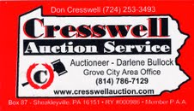

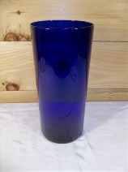
For More Details Please Visit:
www.auctionzip.com
www.paauctioneerbullock.com

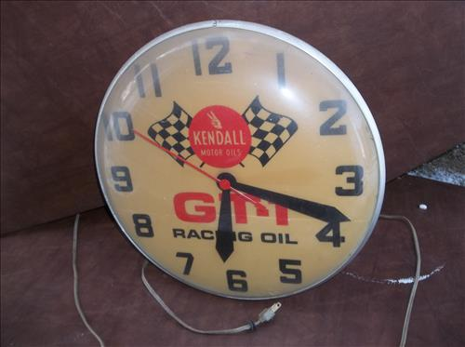
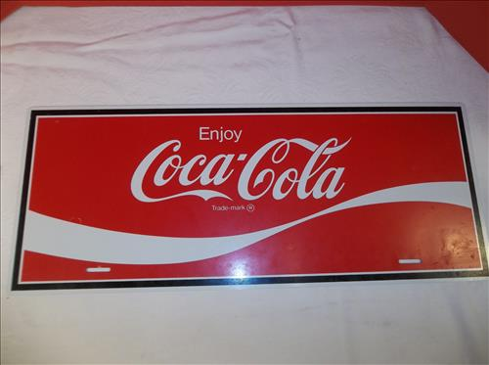
Featuring: Something for Everyone - Wide Variety of Quality Items Up For Auction!

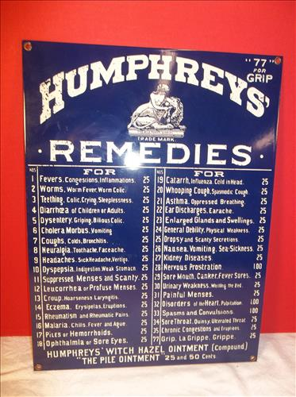
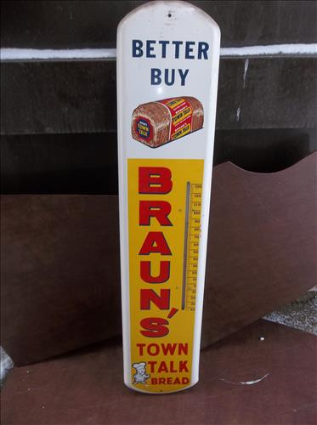
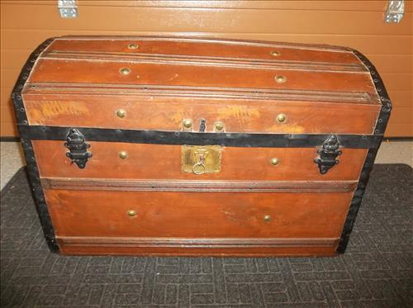
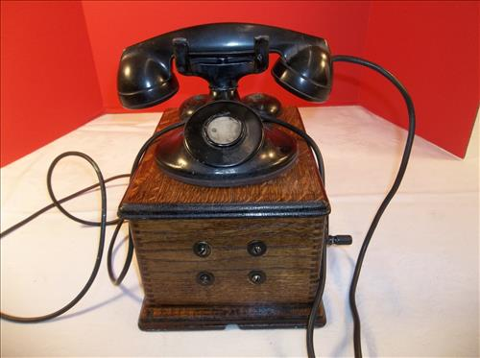
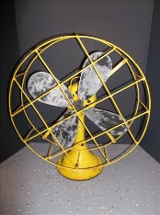
Antiques & Collectibles: Swing Spout Oiler, Griswold Skillet, Wood Box Telephones, Egg Crates, Bubble Gum Machines, 10 Gal. Crock, Crock Jugs, Trunk w/ Tray, Red Jacket Water Pump, Advertising Beer Trays, Advertising Thermometers, Advertising Clocks, Champion Sled, 1960's Ford Mustang Grill, Model A Ford Radiator, Anco Dispenser, Art Deco Lamps & Glasses, Delco Advertising Cabinet, Steel Blade Fans, Thom Thumb Typewriters, Target Master Pistol Game, Emenee Toy Accordion, Gilbert Erector Set, Gilbert Microscope, Red Raven Music Records, Mattel Music Box, Marx Racing Game & Wind-Up Car, Tudor Electric Football, American Logs, Tinker Toys, Stack-A-Clown, Fisher Price Toys, Rock 'em Sock 'em, View Master, Uncle Sam's Register Bank, Glassware: Viking, Fenton, Modern, Carnival, & Candlewick; Ammco Peg Board, Footed Cast Kettle, Kendall Motor Oil & Coco-Cola Signs, Humphrey's Remedies Enameled Sign, Scales, Wood Tool Boxes & Golf Clubs, Griffin Lab Spice Rack & Jars, Sessions Mantle Clock, Cast German Shepard & Cat Door Stops, Cast Trivet Collection, Door Knobs, Wall Pocket Vase, Lanterns, Children's Books, Shenango Pottery, Hamilton Beach Mixer, Wood Zebra Face Mask, Cast Wagner 1920, Corn Planters, Phoenix & Brass Lamps, Hall Jewel Tea, Tea Pots, Bugle, McCoy Vases, Bear Cookie Jar, Black Americana, Stoneware Bowls, Indian Clubs, Utensils, Flatware, Boat Anchors, Lamb Mold, 1950's Bessemer, Milk Bottles, Quilts, Lifetime Electric Skillet, Art Deco Buffet Server, Stereoscope Cards, Small & Large Oriental Rugs, Marx Doll House, African Woodwares & Dolls & Drums; Watt Ware Soup Bowls, Cobalt Blue Vase, Glass Animals, Westinghouse AM Radio, Alarm Clocks, Nascar Mirror & Picture, Marbles, FireKing Jadeite Mugs, Rain Stick, Copper Bucket, Large Brass Kettle, Schweppes Advertising Crate, Royal Haeger & Shawnee Vases, Belleek & Copenhagen Plates, Remington Rand Typewriter, LLadro Figures, Goebel Figure, Minolta Camera w/Lens, Accordion & MORE…
Jewelry, Coins and Stamps: Costume Jewelry, 10K Ring, 14K Bracelet, Silver Halves & Dimes, Silver American Eagle, Wartime Nickels, 1909 VDB Pennies, Steel Wartime Pennies, 1844 Large Cent, Mint Denmark & France Stamps and MORE...
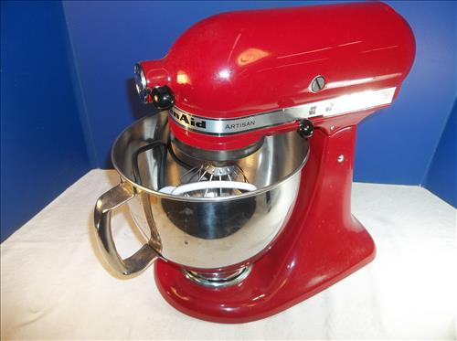
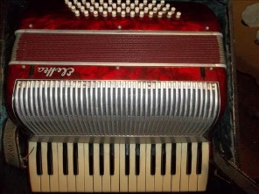
Furniture: Victorian Love Seat, Vintage Oak Book Case & Cupboard, Serpentine Oak Dresser w/Mirror, Small Pine Table, Single Drawer Stand, 2 Singer Treadle Base Tables, Table, Vintage Chairs, Book Shelves, Ice Cream Parlor Stool, Metal Lawn Chair Rocker, RCA Victor Phonograph Victrola, Outdoor Furniture, Telephone Stand Table, Oak Pedestal Plant Stand, Metal Hall Tree, TV Stands, Wicker Tea Cart, Bamboo Cushioned Chairs & Table, Kitchen Table, 4 Drawer Dresser, Unusual Wood Side Stands, School Desk & ETC...
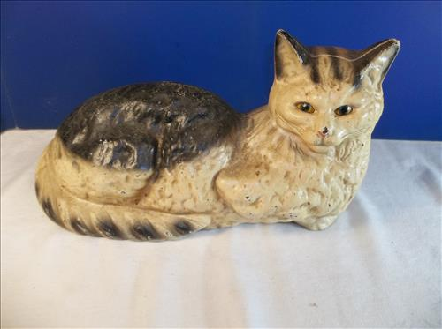
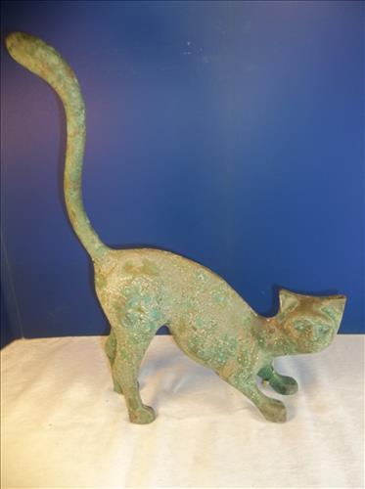
Household Items & Other Misc Items: Stihl Chain Saw, Kitchenaid Stand Mixer, Indian 5 x 8 Wool Rug, Area Rugs, Linens, Crystal Glasses, Cuisinart Coffee Maker, Cd's, Lamps, Electric Heat Surge Heater, Designer Purses, Binoculars, Crystal Stemware, Halloween, Black Walnut Bowl, Coleman Cooler, "New Yorker" Cheese Plates, Sunbeam Mix Master, Hand Tools, C-Clamps, Pots, Small Cage & More..
CALL 724-372-1066 OR 814-786-7129 for more info!
Darlene Bullock - Auctio neer - AU5406 L

